1. **BIT TIMER DESIGN SPECS**
2. **Function and Feature**
   1. **Function**

This IP CORE can be used as a 8-bit Counter/Timer with Overflow/Underflow detect ability

* 1. **Feature**

- Count Up / Down

- Count from initial value

- Can be manual stop/continue to count

1. **Over view block diagrams**

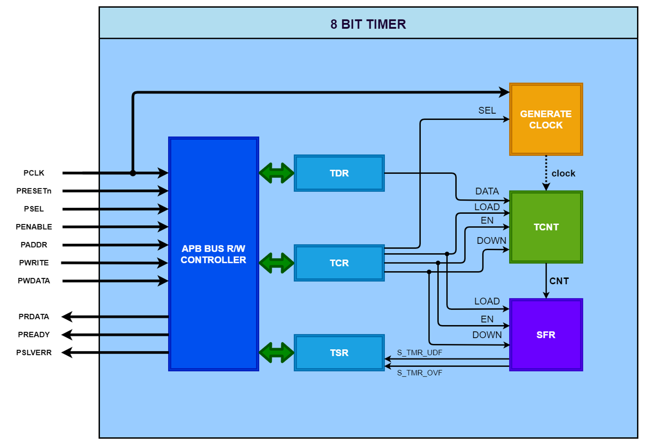

1. **I/O of IP Core**

|  |  |  |  |
| --- | --- | --- | --- |
| **PORT NAME** | **I/O** | **BITWIDTH** | **DESCRIPTION** |
| PCLK | input | 1 | Clock. The rising edge of PCLK times all transfers on the APB. |
| PRESETn | input | 1 | Reset. The APB reset signal is active LOW. This signal is normally connected directly to the system bus reset signal. |
| PSEL | input | 1 | Select. The APB bridge unit generates this signal to each peripheral bus slave such as: TDR, TCR and TSR |
| PENABLE | input | 1 | Enable. This signal indicates the second and subsequent cycles of an APB transfer. |
| PADDR | input | 8 | Address. This is the APB address bus. |
| PWRITE | input | 1 | Direction. This signal indicates an APB write access to TDR, TCR, TSR when HIGH and an APB read access from TDR, TCR, TSR when LOW. |
| PWDATA | input | 8 | Write data. |
| PRDATA | output | 8 | Read data. |
| PREADY | output | 1 | Ready. The slave uses this signal to extend an APB transfer. |
| PSLVERR | output | 1 | This signal indicates a transfer failure. |
| **I/O TABLE OF 8-BIT TIMER** | | | |

1. **Detail block diagram**
   1. **Generate clock**

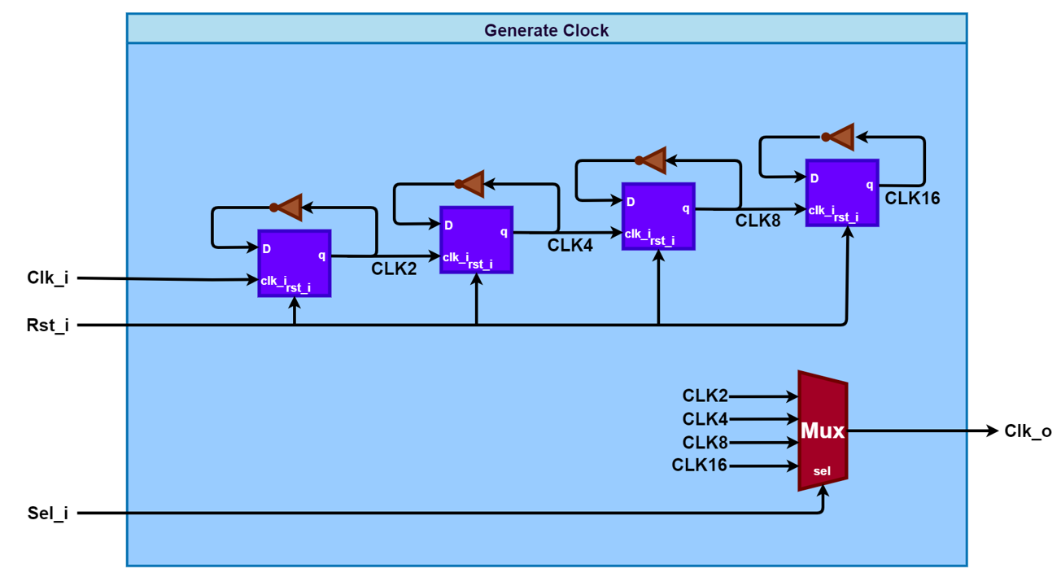

|  |  |  |  |
| --- | --- | --- | --- |
| **PORT NAME** | **I/O** | **BITWIDTH** | **DESCRIPTION** |
| PCLK | input | 1 | System clock |
| CKS | input | 1 | Select internal clock |
| CLK_IN | input | 1 | Internal clock |
| **I/O TABLE OF GENERATE CLOCK** | | | |

* 1. **Counting block**

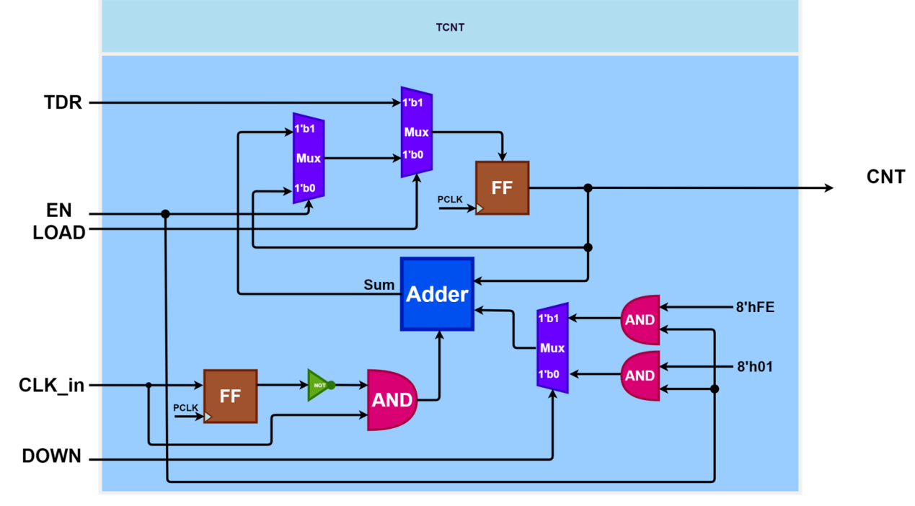

|  |  |  |  |
| --- | --- | --- | --- |
| **PORT NAME** | **I/O** | **BITWIDTH** | **DESCRIPTION** |
| TDR | input | 8 | Initial value for timer counter |
| EN | input | 1 | Enable counter |
| LOAD | input | 1 | Load initial value from TDR register to timer counter |
| CLK_in | input | 1 | Internal clock |
| DOWN | input | 1 | Select mod timer counter are up or down count |
| CNT | output | 8 | Counter value |
| **I/O TABLE OF COUNTING BLOCK** | | | |

* 1. **Special Function Register**

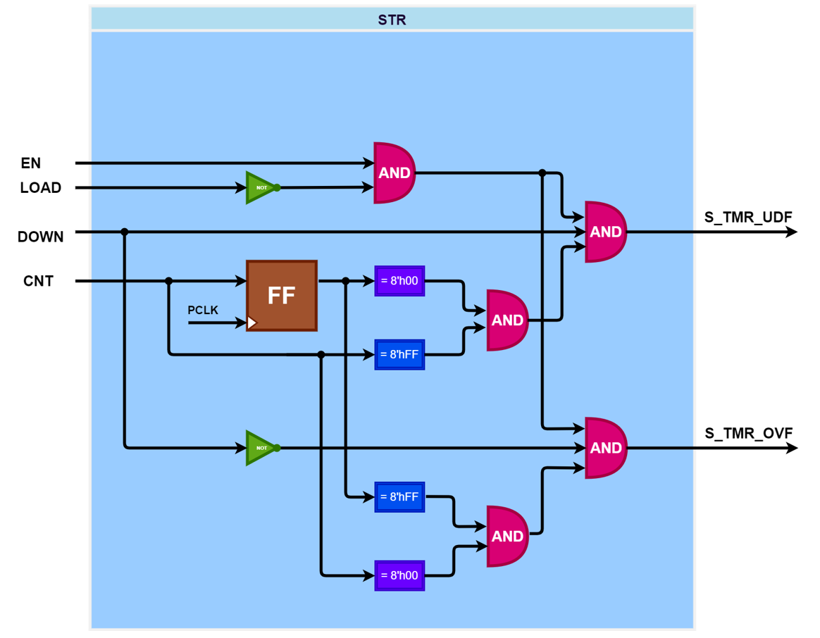

|  |  |  |  |
| --- | --- | --- | --- |
| **PORT NAME** | **I/O** | **BITWIDTH** | **DESCRIPTION** |
| EN | input | 1 | Enable/Disable |
| LOAD | input | 1 | Load initial value for timer counter from TDR |
| DOWN | input | 1 | Select mod count UP/DOWM |
| CNT | input | 1 | Counter value |
| S_TMR_UDF | output | 1 | Signal indicates when counter is underflow |
| S_TMR_OVF | output | 1 | Signal indicates when counter is overflow |
| **I/O TABLE OF TIMER STATUS REGISTER** | | | |

* 1. **APB Bus R/W Controller**

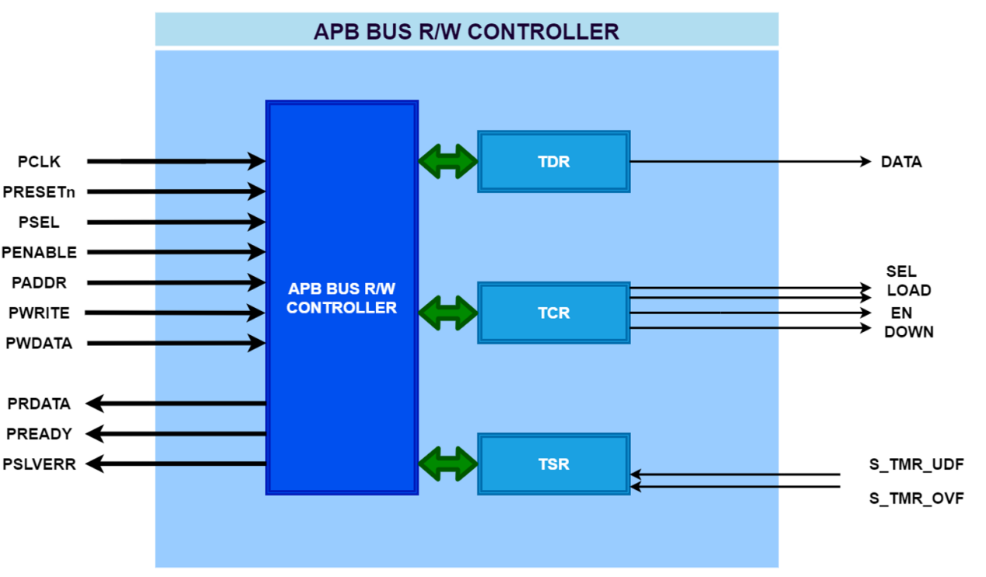

|  |  |  |  |
| --- | --- | --- | --- |
| **PORT NAME** | **I/O** | **BITWIDTH** | **DESCRIPTION** |
| PCLK | input | 1 | Clock. The rising edge of PCLK times all transfers on the APB. |
| PRESETn | input | 1 | Reset. The APB reset signal is active LOW. This signal is normally connected directly to the system bus reset signal. |
| PSEL | input | 1 | Select. The APB bridge unit generates this signal to each peripheral bus slave such as: TDR, TCR and TSR |
| PENABLE | input | 1 | Enable. This signal indicates the second and subsequent cycles of an APB transfer. |
| PADDR | input | 8 | Address. This is the APB address bus. |
| PWRITE | input | 1 | Direction. This signal indicates an APB write access to TDR, TCR, TSR when HIGH and an APB read access from TDR, TCR, TSR when LOW. |
| PWDATA | input | 8 | Write data. |
| PRDATA | output | 8 | Read data. |
| PREADY | output | 1 | Ready. The slave uses this signal to extend an APB transfer. |
| PSLVERR | output | 1 | This signal indicates a transfer failure. |
| **I/O TABLE OF R/W CONTROLLER BLOCK** | | | |

1. **Register table**
   1. **TDR**

|  |  |  |  |  |  |  |  |
| --- | --- | --- | --- | --- | --- | --- | --- |
| **TDR** | **8’h00** | | | | | | |
| **Bit 7** | **Bit 6** | **Bit 5** | **Bit 4** | **Bit 3** | **Bit 2** | **Bit 1** | **Bit 0** |
| TDR[7] | TDR[6] | TDR[5] | TDR[4] | TDR[3] | TDR[2] | TDR[1] | TDR[0] |

|  |  |  |
| --- | --- | --- |
| **Bit Name** | **R/W** | **Description** |
| TDR[7:0] | R/W | Data used for initial the value for timer counter |

* 1. **TCR**

|  |  |  |  |  |  |  |  |  |
| --- | --- | --- | --- | --- | --- | --- | --- | --- |
| **TCR** | **8’h01** | | | | | | | |
| **Bit 7** | **Bit 6** | | **Bit 5** | **Bit 4** | **Bit 3** | **Bit 2** | **Bit 1** | **Bit 0** |
| Load | Reserved | | Up/Down | En | Reserved | Reserved | Cks1 | Cks0 |
| **Bit Name** | | **F/W** | | **Description** | | | | |
| Load[7] | | R/W | | Manual load data from TDR to TCNT when it active High.  1: load data to TCNT  0: Normal operation. | | | | |
| 6 | | Reserved | | Reserved | | | | |
| Up/Down[5] | | R/W | | Control counter up or counter down  0: counter up  1: counter down | | | | |
| En[4] | | R/W | | 0 : disable  1: enable | | | | |
| 3:2 | | Reserved | | Reserved | | | | |
| Cks[1:0] | | R/W | | Select internal clocks for circuit  00 : T*2  01 : T*4  10 : T*8  11 : T*16 | | | | |

* 1. **TSR**

|  |  |  |  |  |  |  |  |
| --- | --- | --- | --- | --- | --- | --- | --- |
| **TSR** | **8’h02** | | | | | | |
| **Bit 7** | **Bit 6** | **Bit 5** | **Bit 4** | **Bit 3** | **Bit 2** | **Bit 1** | **Bit 0** |
| Reserved | Reserved | Reserved | Reserved | Reserved | Reserved | S_TMR_UDF | S_TMR_OVF |

|  |  |  |
| --- | --- | --- |
| **Bit Name** | **F/W** | **Description** |
| TSR[7:2] | Reserved | Reserved |
| S_TMR_UDF[1] | R/W* | Timer counter underflow when counter 8’h00 down to 8’hff:  This bit is only set by hardware, clear by software |
| S_TMR_OVF[0] | R/W* | Timer counter overflow when counter 8’hFF to 8’h00:  This bit is only set by hardware, clear by software |

1. **Timing chart**
   1. **Counter Up**

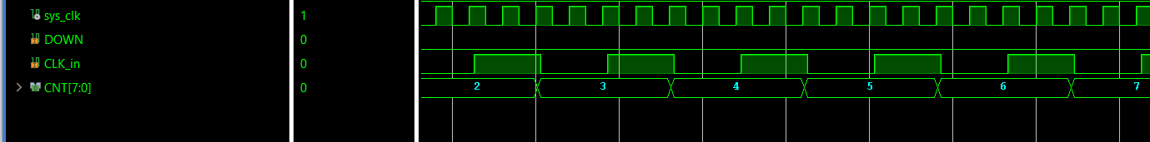

* 1. **Counter Down**

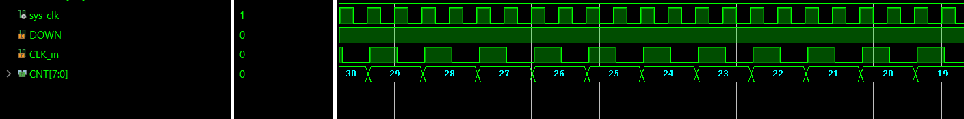

* 1. **Overflow**

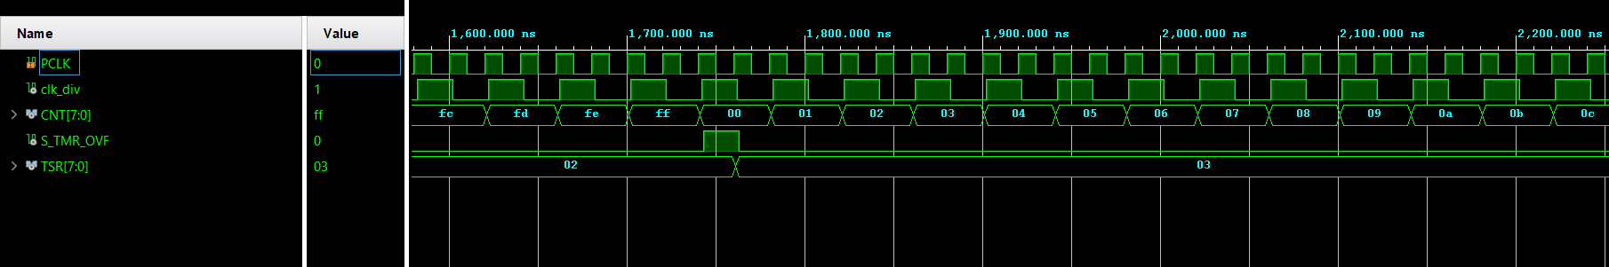

* 1. **Underflow**

